Introduction to JIRA

Introduction to JIRA: -
- JIRA is developed by Atlassian Inc., an Australian Company introduced Jira in 2002.
- JIRA is a project management tool. A bug tracking and agile project management is allowed in software companies.
- JIRA is a Japanese word “Gojira” is a word from which JIRA is inherited which means “Godzilla”.
Overview of JIRA:-
- Jira is a suite of agile work management solutions that powers collaboration across all teams from concept to customer, empowering you to do the best work of your life, together.
- Jira offers several products and deployment options that are purpose-built for Software, IT, Business, Ops teams, and more. Read on to see which is right for you.

Jira products overview: -
- JIRA Software: -
- Built for every member of your agile team and beyond to plan, track, and ship world-class software.

- JIRA Service Management: -
- Give your customers an easy way to ask for help and your agents a faster way to deliver it.

- JIRA Work Management: -
- Manage any business project including marketing campaigns, HR onboarding, approvals and legal document reviews.

- JIRA Align: -
- Enterprise Agile Planning platform that connects product, program, and portfolio strategy to technical execution, at scale.
JIRA Users :-
According to Atlassian, Jira is used for issue tracking and project management by over 180,000 customers in 190 countries.

Use of JIRA
Following are some of the most significant uses of JIRA.
- JIRA is used in Bugs, Issues and Change Request Tracking.
- JIRA can be used in Help desk, Support and Customer Services to create tickets and track the resolution and status of the created tickets.
- JIRA is useful in Project Management, Task Tracking and Requirement Management.
- JIRA is very useful in Workflow and Process management.

Workflow of JIRA Software:-
The following diagram shows a standard workflow −

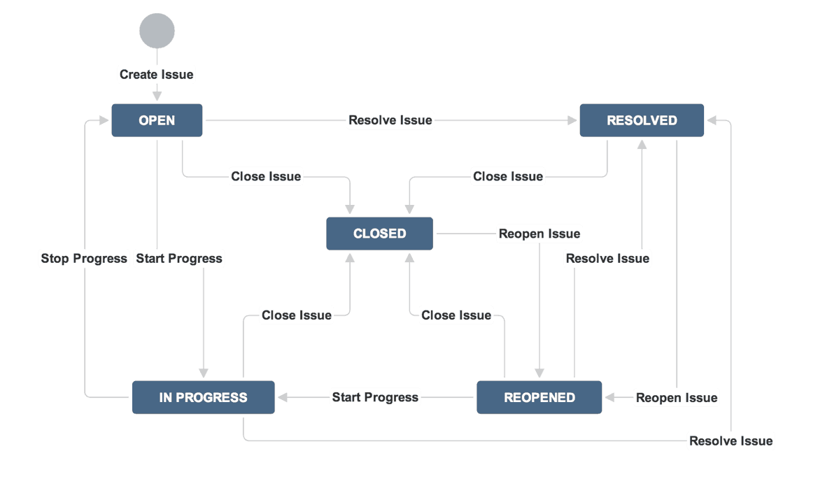
- In JIRA, workflow is used to track the lifecycle of an Issue. Workflow is a record of statuses and transitions of an issue during its lifecycle.
- A status represents the stage of an issue at a particular point. An issue can be in only one status at a given point of time like Opened, To Do, Done, Closed, Assigned, etc.
- A transition is a link between two statuses when an issue moves from one status to another. For an issue to move between two statuses, a transition must exist.
- JIRA Workflow can be referred as a Defect Lifecycle. It follows the same concepts; the only difference is that it is generic for all issues rather than limited to Defects only.

Explanation of workflow in Jira:-
- As of now, an issue is created and opened. When the assignee person starts working on the issue, the issue moves to the In-Progress status. Here, the transition is starting the work, while the status of the issue is now progressive.
JIRA workflow has the following stages to track as soon as an issue is created −
- Open Issue − After creation, the issue is open and can be assigned to the assignee person to start working on it.

- In Progress Issue − The assignee person has actively started to work on the issue.
- Resolved Issue − All sub-tasks and works of that Issue are completed. Now, the issue is waiting to be verified by the reporter. If verification is successful, it will be closed or re-opened, if any further changes are required.
- Reopened Issue − This issue was resolved previously, but the resolution was either incorrect or missed a few things or some modifications are required. From Reopened stage, issues are marked either as assigned or resolved.
- Close Issue − The issue is considered as finished, resolution is correct as of now. Closed issues can be re-opened later based on the requirement.
Basic Concepts of JIRA:-
Here are three fundamental Jira concepts to understand:
- Issue – an individual item in Jira.
- Project – a collection of Jira issues.
- Issue Type – a classification of issues in a Jira project.

Issue, Project, Workflow, Components & Versions in JIRA Software: -
Issue in JIRA Software:-
An issue helps to track all works that underlie in a project. In real time, every work or task either technical, non-technical, support or any other type of a project in JIRA are logged as an issue.
An issue can be dependent on the organization and requirements −
- Story of a project
- Task of a story
- Sub-task of a story
- A defect or bug can be an issue
- Helpdesk Ticket can be logged as issue
- Leave Request
Since JIRA tracks all the tasks, the sub-tasks or even a work as an Issue, there are several types of Issues to identify the work and categorize the similar issues.

Types of Issue is classified as follows −
- Sub-Task − This is the sub-task of an issue. In a logged issue, there can be different tasks to resolve it, which are called as sub-tasks.
- Bug − A problem that impairs or prevents the functions of the product.
- Epic − A big user story that needs to be broken down. Created by JIRA Software - do not edit or delete.
- Improvement − An improvement or enhancement to an existing feature or task.
- New Feature − A new feature of the product, which is yet to be developed.
- Story − A user story. Created by JIRA Software - do not edit or delete.
- Task − A task that needs to be done to achieve team’s goal.

Project Issues in JIRA: -
A Project contains issues; a JIRA project can be called as a collection of issues. A JIRA Project can be of several types. For example −
- Software Development Project
- Marketing Project
- Migration to another platform project
- Help Desk Tracking Project
- Leave Request Management System
- Employee Performance System
- Website Enhancement.
Workflow Issue in JIRA: -
- You can assign the status of the issue from the window itself, when you click on the check box for IN Progress status as shown in screen shot below.
- it will reflect the status in the issue panel highlighted in yellow. For the issue that we have created, JIRA will present a workflow which maps the progress of the project.
- As shown in screenshot whatever status that we have set in the Issue panel it will be reflected in Workflow chart, here we have set the issue status in “In Progress” and same status is updated in the workflow, highlighted in yellow.
- Workflow can give a quick overview of the work under process.
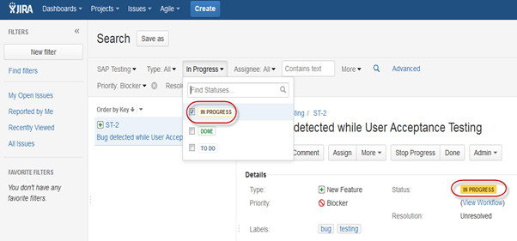

JIRA Components and Versions:-
Jira Components are sub-sections of a project; they are used to group issues within a project into smaller parts. Components add some structures to the projects, breaking it up into features, teams, modules, subprojects and more. Using components, you can generate reports, collect statistics, and display it on dashboards and so on.
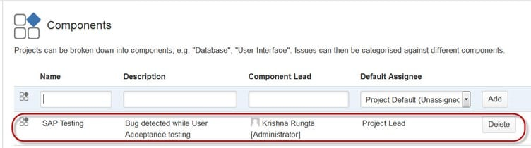
To add new components, as shown in the above screen you can add name, description, component lead and default assignee.

Versions in JIRA Software: -

WHAT IS A VERSION IN JIRA SOFTWARE?
In Jira Software, versions represent points-in-time for a project. They help you organize your work by giving you milestones to aim for. You can assign issues in your project to a specific version, and organize your sprints around completing work in that version.
How to create version in JIRA software:-
The following steps are:

Step:1 Create a version in Jira Software

A version is a set of features and fixes released together as a single update to your product.

What is JIRA Software?
- JIRA is a tool developed by Atlassian. This software is used for bug tracking, issue tracking, and project management.
- It is also used for project management. The JIRA dashboard consists of many useful functions and features which make handling of issues easy.

Priority of Issues in JIRA:-
By default, issues in Jira can have one of five priority levels:
- Lowest,
- Low,
- Medium,
- High,
- Highest.
You can easily set this by opening up a particular issue and then selecting it under ‘Priority’. Just click on the current priority level to open up a dropdown menu of the available priorities.

Overview of Projects:-

What is a project in Jira Software?
- Your issue tracker should be the hub of your development project. Jira Software helps your team members prioritize and organize work better, so they can spend more time developing great software instead of wrangling issues.
- A project is simply a collection of issues (stories, bugs, tasks, etc). You would typically use a project to represent the development work for a product, project, or service in Jira Software.

Scrum, Kanban, or Bug tracking?
- Scrum has an iteration-based approach, which is generally a good fit for teams developing products, particularly if your team is releasing new versions on a regular schedule.
- Kanban is better suited for a continuous flow of work (e.g. service-oriented teams), where its constraint-based approach helps prevent your team from being overloaded.
- Bug tracking delivers a basic workflow for tracking new features and bugs.
- Our team-managed Scrum and Kanban projects are great for teams who are new to agile. Get your team up-and-running with this simplified board-view project template.

Sub Tasks in JIRA Software: -
- Sub-tasks are created in an issue and assigned to the concern person. Once all the sub-tasks are resolved, the issue can be marked as completed.
- Sub-tasks An issue can be completed by performing many tasks with different persons like Dev, QA, UAT, Business, Support, etc. To track the progress in each department.

Hands-on JIRA :-
Login to JIRA:-
- To login to JIRA, go to your sample website.
- It will open a login page. Fill in your registered email address/username and Password. Click on the Login button.
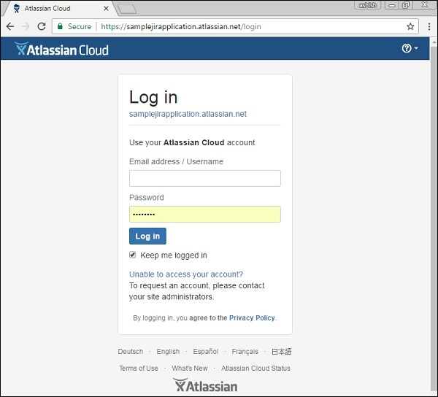

Common Login Errors
- In case of any unsuccessful login, an error message display.
- The following screenshot shows the error message a user receives, if the credentials are not matching or incorrect.
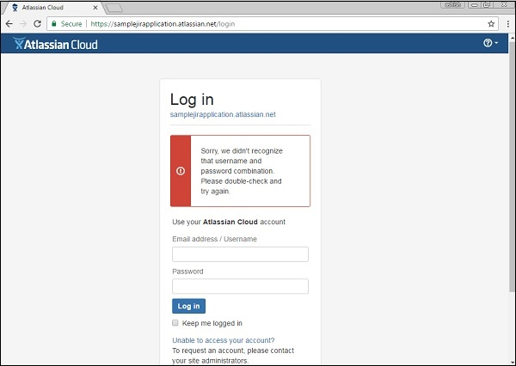
- To rectify this scenario, click on “Unable to access your account”, then select the appropriate option and fill in the details.
- Click on email. The following screenshot shows how to recover the username, in case the user has forgotten it.
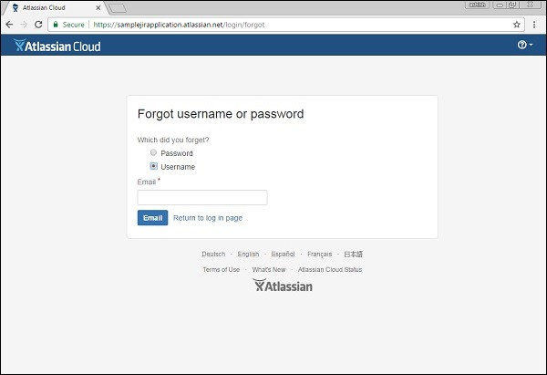
- The user will get an email with the details of his username or a link to reset the password.

Successful Login
- On a successful login, the system dashboard will display if the account is associated with any project by the admin, or if a user can create a sample project as explained in the earlier chapters.
- The following screenshot displays the welcome page/dashboard of JIRA on a successful login.
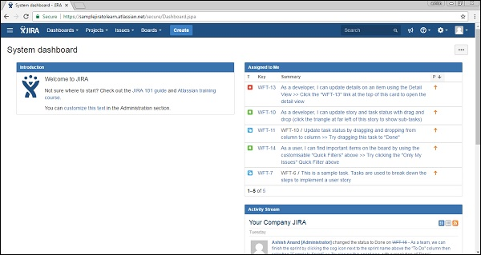
Create a Project in JIRA:-

Jira Epic
- Jira epic is a large user story which is broken into smaller tasks (user stories) based on the customer or end-user needs.
- Based on the customer needs, the task is added or removed from the epic as necessary.
- Epics are used to organize the work and to create a hierarchy.
- Epics maintain the agility by organizing larger tasks into smaller tasks.
- Epic is the top-tier of the work hierarchy, which is used by the developers.
- Epics are larger stories which have distinct start and end.
- Epics can span to multiple sprints, i.e., the epics are delivered over the multiple sprints.
- Epics can contain stories, bugs, and tasks within them, and grouping them makes a large story.
- When epics contain stories, bugs, or tasks, then all these issue types are represented at the same level in a hierarchy in Jira.
- Stories, bugs, tasks represent a single piece of work, while epic is a group of related issues.
Let's understand the structural flow of an Epic:
Epics are composed of multiple stories, while Initiatives are made up of Epics. Therefore, we can say that initiatives come above the epics. Initiative takes the Epics from the multiple teams to achieve a bigger goal than any of the Epics can achieve themselves.
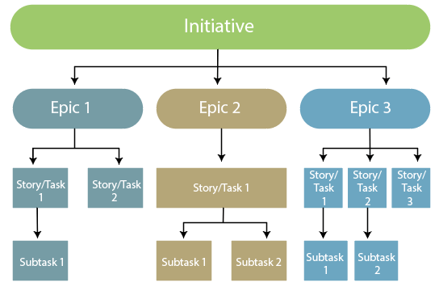

Working of Epic

Creating an Epic
There are two ways of creating an epic:
- Creating an epic from a new issue
Step 1: Click on the '+' icon appearing at the left side of the panel.
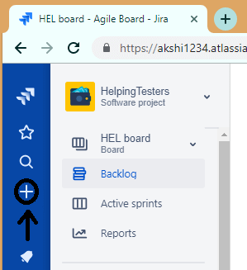
Step 2: On clicking the + icon, the screen appears, which is shown below:
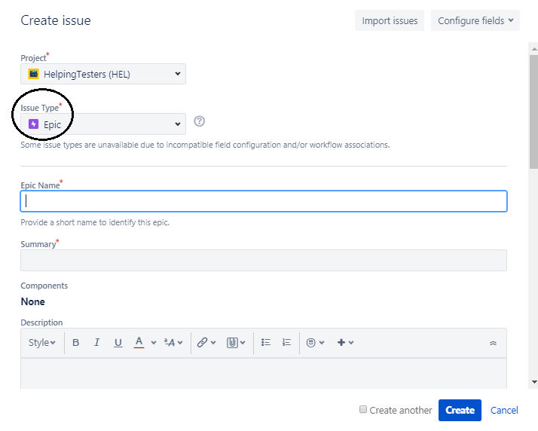
Step 3: Select the issue type as Epic.
- Creating an epic from the Epics panel
Step 1: Click on the Backlog appearing at the left side of the panel.
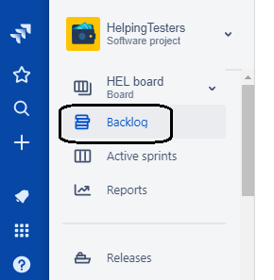
Step 2: Click on the Epics shown in the epics panel.
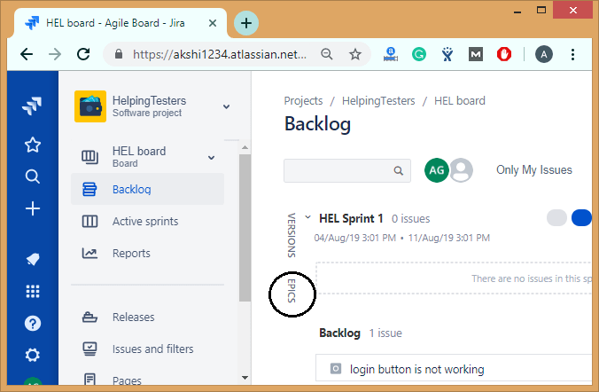
Step 3: Click on the Create Epic link.
In the above two cases, you need to enter the following details in order to create the epic:
- Epic name: It is a short and unique identifier of an epic.
- Epic summary: It provides a short description of an epic.

Add and Remove stories
There are two ways of adding stories in epic:
- Adding an issue from the issue create screen
Step 1: Click on the + icon appearing at the left side of the panel.
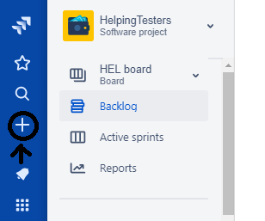
Step 2: Click on the dropdown of issue type and select an issue type other than epic.
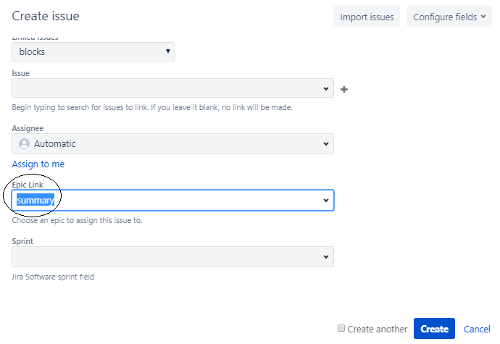
The above screen shows that we have created an issue of type Bug and we add this issue in an epic "Summary". We add the epic in an Epic Link field.
- Adding an issue from the Epics panel
Step 1: Click on the Backlog appearing at the left side of the panel.
Step 2: Click on the Epics from the Epics panel.
Step 3: Click on the create issue in epic link.
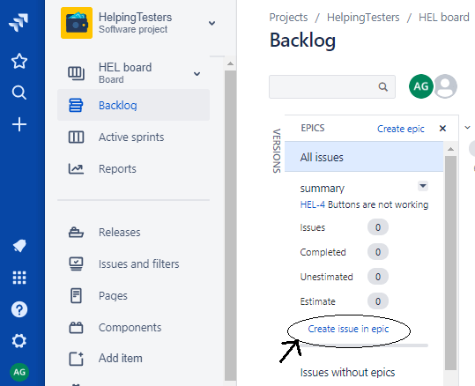
- Removing an issue from the epic
To remove an issue from the Epic, follow the steps which are given below:
Step 1: Move to the Backlog page.
Step 2: Drag and drop the issue to issues without epics.
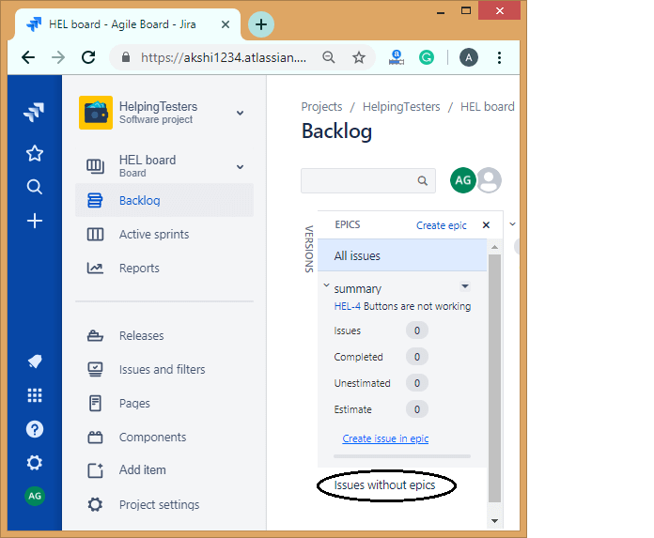

Viewing all your Epics
We can see the information related to your epic in the Backlog.
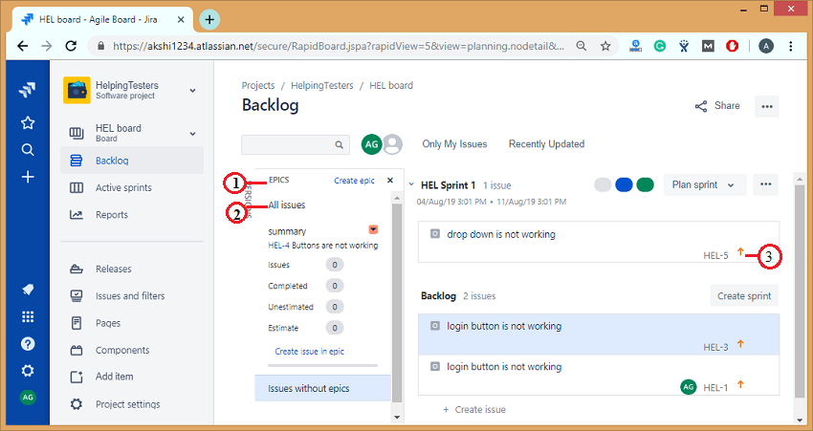
- Epics panel: Navigate to the Backlog and then click on the Epics panel to view and manage your epics.
- List of Epics: The Epics panel shows the list of all the epics in your project.
- View issues in epic: Click on the epic's name to view all the issues available in an epic across all the sprints.

Complete your Epic
Once all the work related to an epic is completed, then the epic is marked as complete.
The following are the steps required to complete an epic:
- Click on the Backlog appearing at the left side of the panel.
- Click on the Epics from the Epics panel.
- Select the epic to which you want to mark it as Done.
- Click on the dropdown and select the option "Mark as Done".
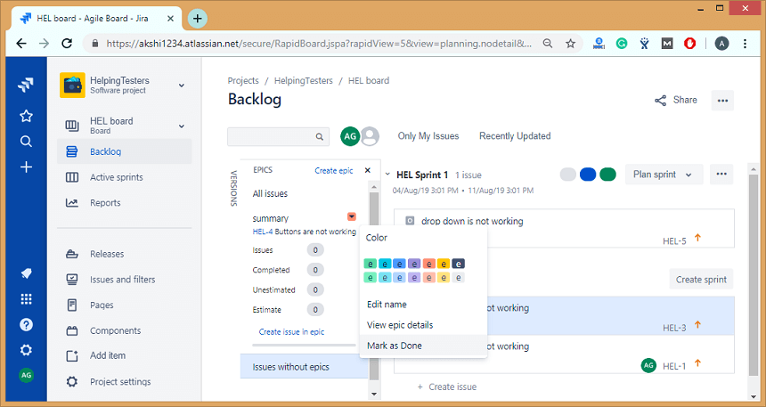
When you mark the epic as Done, then the dialog box appears asking for the confirmation.

Kanban vs Scrum
There are many differences between Kanban and Scrum. A list of differences between Kanban and Scrum are given below:
 | Scrum | Kanban
Planning | It has fixed planning. It focussed on planning. It starts with the sprint planning and ends with the sprint review, retrospective. The daily meeting is held so that the team knows the next steps, priorities, and the learnings from the previous steps. | It has no fixed planning, and no daily meetings are conducted. In Kanban, changes can occur at any time, i.e., frequent changes occur.
Timeline | In scrum, we work on the sprint that has the fixed-time duration means that after some fixed-time, we are delivering something to the client. | Kanban does not have the concept of a sprint, so it has no fixed timeline for delivering the product to the client.
Task estimates | During sprint planning, it is decided that how many activities are to be pulled from the product backlog and add in a sprint backlog. For example, if the sprint is for two weeks, then the number of activities are selected in such a way that they can be completed within the sprint, i.e., in two weeks. | It does not estimate the task.
Scrum Master | In scrum methodology, we have one scrum master who handles the team and conducts the meeting on a daily basis. | In Kanban methodology, we do not have any scrum master. It's the responsibility of each individual to deliver a valuable product.
Suitability | This methodology is suitable for large-sized projects as large-sized projects can be divided into multiple sprints. | It is mainly suitable for small-sized projects.
Constant changes | In Scrum, constant changes can be adapted easily in shorter sprints. | If any major change occurs, then Kanban methodology gets failed.
Cost | In Scrum, the task is estimated, i.e., a fixed number of activities are taken in a sprint, so the total cost of the project is minimal. | In Kanban, the task is not estimated, so the total cost of the project is not accurate.
Roles and responsibilities | In Scrum, a specific role is assigned to the team members by the Scrum Master while the product owner tells the objectives of the product on which team members have to work. | No predefined role is assigned to the team members. It's the responsibility of all the team members to work in collaboration to deliver a valuable product.
Measurement of Productivity | The productivity is measured by using cycle time or the time taken to complete the whole project from start to the end. | Productivity is measured by using velocity through sprints.
Release Methodology | Small release after the end of each sprint. | It provides continuous delivery.

What is an Issue?
JIRA Issue is used to track the individual pieces of work that has been completed or not. JIRA issue can be a software bug or any other issue. Once you have imported the project in Jira, you can create issues.
Issue types
Teams work together to break down the pieces of work into issues. Issues can represent software bugs, a project task, subtasks, or any other project work. Jira project comes with the default issue type, and you can also create your own issue type.
An issue type is a generic name for the unit of work. In Jira, we have different units of work in a project, and issue types field differentiate this.
When you create an issue, then you need to specify the issue type. You can even change the issue type after creating the issue.
Each issue has an icon associated with it to identify the issue type.
Custom Issue type: It is also used to create the customization issue type that provides the flexibility to the team to create their own issue types according to their projects
The below screen shows the list of Issue types:
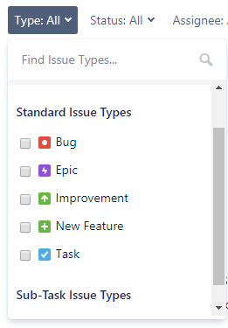
There are three types of Issue types:
- JIRA Core Default Issue types
  - Task: The task is a work item done by the team but not connected directly to the user's requirements. For example, to upgrade the version of a product used by the teams.
  - Subtask: It is a part of another issue. It is used to break an issue into different pieces of work. While creating an issue, sub task issue is not given in the issue type field drop-down as it contains some parent issue, so we can say that subtask issue cannot be created independently.

- JIRA Software default issue types
  - Story: It is a requirement from the user's perspective.
  - Bug: It is a flaw in a product that needs to be fixed by the developers. It can be tracked with its own issue type to differentiate from other types of work.
  - Epic: An epic is a big issue that contains other issues.

- JIRA Service desk default issue types
  - Incident
  - Service Request
  - Change
  - Problem

Why Issue types?
Issue types are used because of the following reasons:
- They support multiple work items. Usually, teams contain multiple work items, and issue types are used to differentiate these work items.
- Each Issue type can have different fields, screens, and workflows. For example, the bug appears on the top of the project board.
- You can report issue types separately. Issues are categorized by issue types; for example, you want to report the progress of your work of the previous week.
Subtask
- Subtask is an issue type that must have a parent issue.
- To create a subtask, click on the create subtask icon for the parent issue.
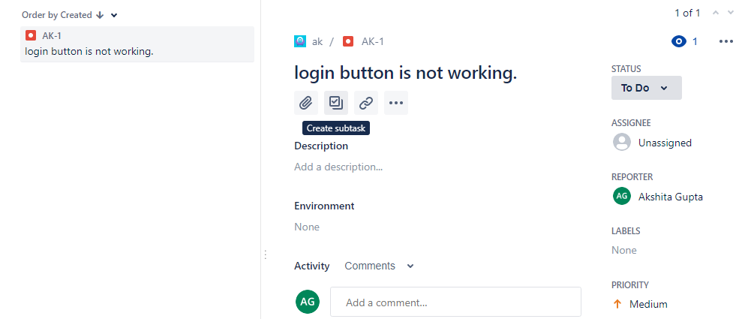
- It converts an issue into individual manageable tasks, and each task is assigned to the team members.
- Subtask is more technical than the parent issue. For example, the type of issue is the Story, then the lines written in story will be non-technical, so that team members and stakeholders can understand. But the subtasks are written in technical line implementing subtasks.
Subtask Characteristics
- Subtask has its own issue key and fields.
- Subtasks have independent workflow status
- Subtask issue type can be converted into another issue.

Converting a Sub-task to issue
- Move to the details of a subtask and then click on the more(...) button, and then click on the Convert to Issue.
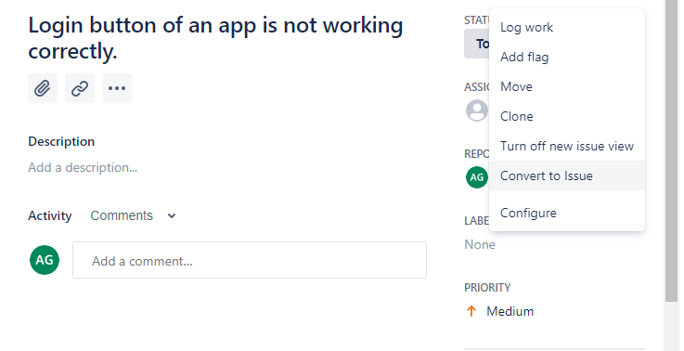
- On clicking on the Convert to Issue, the screen appears which is shown below. You can select the issue type of your choice.
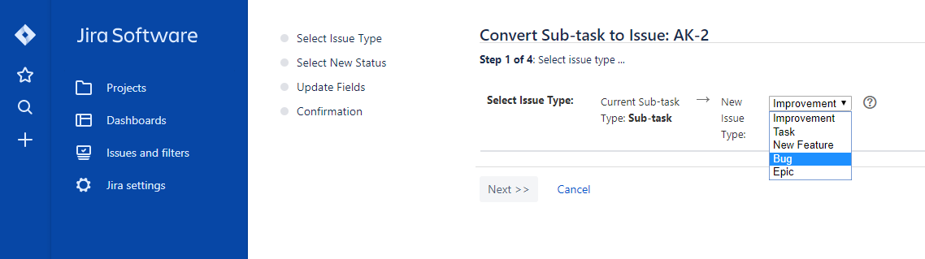

Converting an issue into Subtask
- Open the issue that you want to convert into a subtask.
- Click on the on (...) button, then drop down menu will be opened.
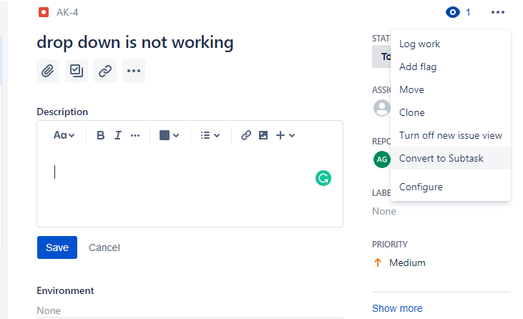
- Click on the Convert to Subtask menu item. On clicking on the Convert to Subtask, the screen appears which is shown below:
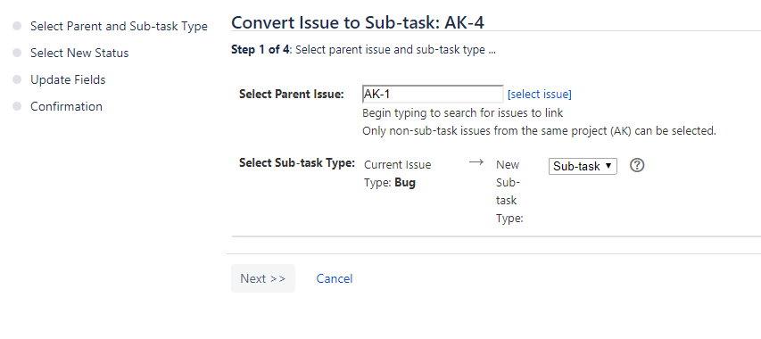
In the above screen, select the parent issue and then click on the Next>>.
- The below screen shows that Step 2 is not required. Click on the Next>>.
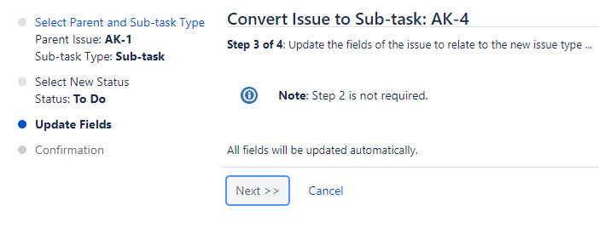
- The below screen is Confirmation. Click on the Finish button.
